**Lab Practical #03:**

Study of different types of network cables & connectors and crimping a LAN.

**Practical Assignment #03:**

1. List various networks cable. Also, w-rite short description.
2. Difference between guided and unguided media.
3. Give cross-wired cable and straight through cable diagram (Color Code wise).

## List various networks cable and connectors. Also, write short description.

1. **Twisted Pair Cable:** 
   * **Description**: This cable has pair of wires twisted together. It is commonly used in homes and offices.
   * **Types**:
   1. **Unshielded Twisted Pair (UTP)**: Most common, used in LAN.
   2. **Shielded Twisted Pair (STP)**: Has extra protection from noise.
   * 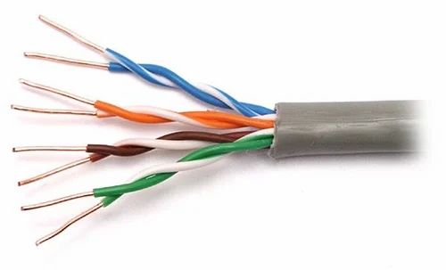**Diagram**:
2. **Coaxial Cable:** 
   * **Description**: This cable has a single copper wire core with insulation, a metallic shield, and an outer cover. It is strong and less affected by noise.
   * **Example Use**: TV cable connection, CCTV
   * 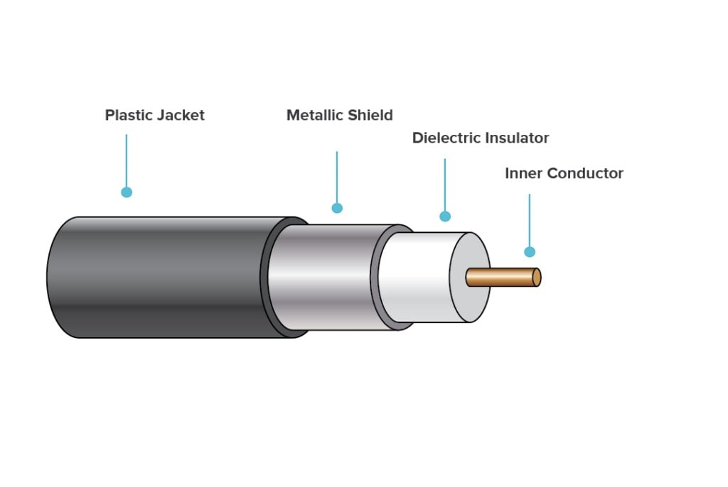**Diagram**:
3. **Fiber Option cable:** 
   * **Description**: This cable uses thin glass or plastic fibers to carry data as light signals. It provides very high speed and long-distance communication.
   * **Example use**: Internet backbone, high-speed networks.
   * **Diagram**:

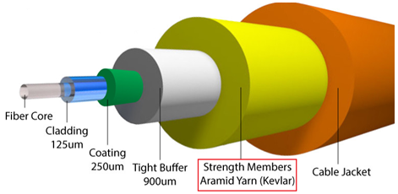

1. **Difference between guided and unguided media.**

|  |  |  |
| --- | --- | --- |
| **Point** | **Guided Media (Wired)** | **Unguided Media (Wireless)** |
| **1. Medium** | Data travels through a **physical path** (like cable). | Data travels through **air/wireless signals.** |
| **2. Examples** | Twisted Pair, Coaxial, Fiber Optic. | Radio waves, Microwaves, Infrared, Satellite. |
| **3. Speed** | Generally **faster** and more secure. | Slower compared to fiber, can be affected by interference. |
| **4. Cost** | Needs cables, so **installation is costly** for long distance. | No cables, so **cheaper** for long distance. |
| **5. Security** | More secure, signals remain inside cables. | Less secure, as signals can be intercepted easily. |
| **6. Usage** | Best for **LAN, office, home networks.** | Best for **Wi-Fi, cellular, satellite, broadcasting.** |
| **7.Reliability** | More reliable for stable connections. | Less reliable, affected by distance and environment. |

## Give cross-wired cable and straight through cable diagram (Color Code wise).

1. Cross-wired Cable Diagram (Color Code)

|  |  |  |
| --- | --- | --- |
| **Pin No** | **T568A (End A)** | **T568B (End B)** |
| 1 | Green-White | Orange-White |
| 2 | Green | Orange |
| 3 | Orange-White | Green-White |
| 4 | Blue | Blue |
| 5 | Blue-White | Blue-White |
| 6 | Orange | Green |
| 7 | Brown-White | Brown-White |
| 8 | Brown | Brown |

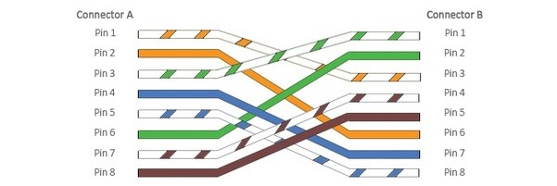

1. Straight Through Cable Diagram (Color Code)

|  |  |
| --- | --- |
| **Pin No** | **Wire Color** |
| 1 | Orange-White |
| 2 | Orange |
| 3 | Green-White |
| 4 | Blue |
| 5 | Blue-White |
| 6 | Green |
| 7 | Brown-White |
| 8 | Brown |

